[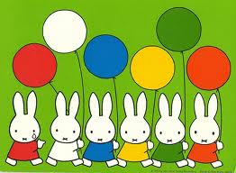](http://www.google.com/imgres?q=match+the+balloons&um=1&hl=ko&sa=X&biw=1280&bih=834&tbm=isch&tbnid=Lh8l96l01Fh3xM:&imgrefurl=http://www.flickr.com/photos/15134271%40N03/4751608575/&docid=j--QrVEBIoxtzM&imgurl=http://farm5.staticflickr.com/4117/4751608575_cab463c0b6_z.jpg&w=640&h=469&ei=j075T_iQFsy02AWU2JjoBg&zoom=1)