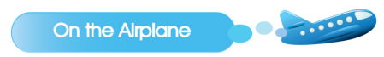

Welcome. Can I see your ticket please?

Here it is.

Your seat is this way.

Thank you.

Please fasten your seatbelt.

**=take off=**

Would you like something to drink?

Yes, Can I have some orange without ice?

Here you are.

Thank you.

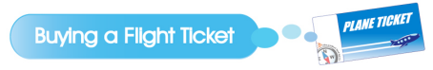

Hi, I’ would like to buy a ticket to New York.

Will that be one way or round trip?

* Round trip tickets, please.
* How much is a round trip ticket?

It’s $500. Will you pay by cash or credit card?

I want to pay by cash. Here it is.

* Where do you want your seat?

Near the aisle or by the window?

 By the window please.

* Okay, Here’s your tickets.
* Your seat is 12A. You need to go to Gate 14. Enjoy your flight.

Thank you.

Take off 이륙하다

without: ~없이

One way: 편도 Aisle: 복도

Round trip: 왕복 Flight: 비행

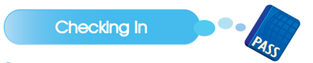

Please put your bag in this basket.



Do you have any liquids exceeding a liter or any explosives?

No,

What’s in your bag?

 I have books, pencils and crayon.

Could you open it?

Sure.

Hmm, everything seems to be okay.

You can go out the green line.

Thank you.

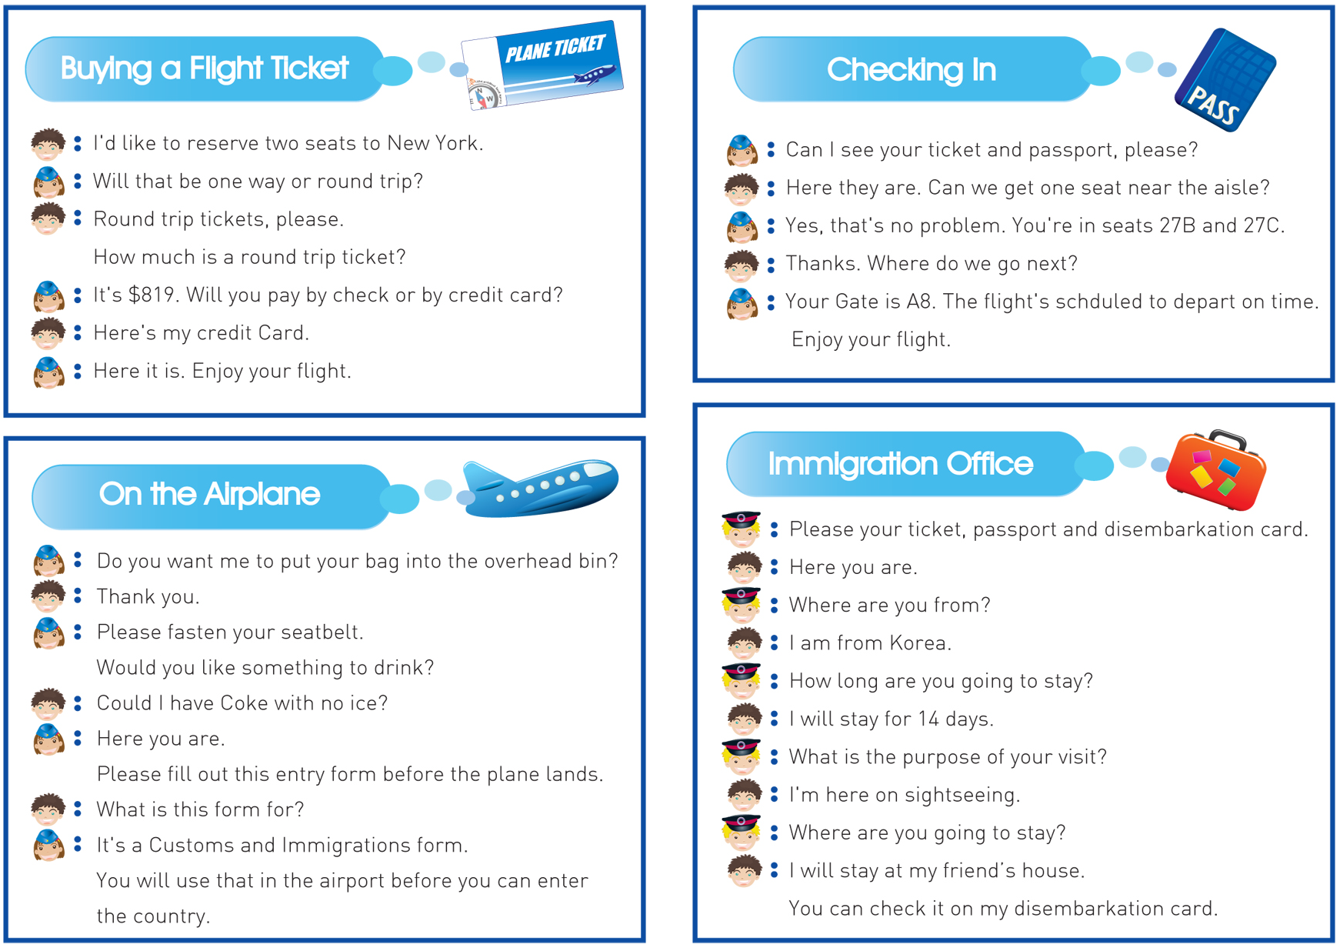

Please show me your passport.

Here you are.

Where are you from?

I am from Korea.

How long are you going to stay?

I will stay for 10 days.

 What is the purpose of your visit?

I’m here on sightseeing.

Where are you going to stay?

I’m staying in a hotel.

 Enjoy your trip.

stay::지내다

purpose: 목적

sightseeing 관광

Liquids: 액체

Explosive: 폭발물

exceed: 넘다

a liter: 1리터