[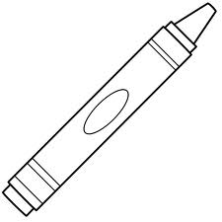](http://www.google.co.kr/imgres?q=color+the+crayon&um=1&hl=ko&newwindow=1&biw=1236&bih=745&tbm=isch&tbnid=7Wf62BF_fDZ79M:&imgrefurl=http://printablecolouringpages.co.uk/%3Fs%3Dpicture%2520of%2520a%2520crayon%2520to%2520color&docid=C2sDgnBAriXXjM&imgurl=http://www.bigactivities.com/coloring/back_to_school/crayons/images/crayon.gif&w=1000&h=1000&ei=wlpVUJbvA8mUiAKX3YGQAQ&zoom=1&iact=hc&vpx=403&vpy=136&dur=344&hovh=225&hovw=225&tx=134&ty=113&sig=103288684120275217025&page=4&tbnh=174&tbnw=174&start=70&ndsp=22&ved=1t:429,r:2,s:70,i:299)

**Short**

**Short**

**Long**

**Long**