[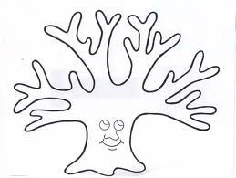](http://www.google.co.kr/imgres?q=tree+outline&start=93&hl=ko&newwindow=1&biw=1236&bih=716&tbm=isch&tbnid=w_4LVfTKbGJRAM:&imgrefurl=http://skyways.lib.ks.us/tricon/2006/events_06.html&docid=Kxwmt8YmrZ9nEM&imgurl=http://skyways.lib.ks.us/tricon/2006/handouts/Tree.jpg&w=2209&h=1667&ei=LWttUL_2K4mRiQKNzYDwAw&zoom=1&iact=hc&vpx=312&vpy=343&dur=344&hovh=195&hovw=259&tx=142&ty=115&sig=112904151372747464820&page=5&tbnh=137&tbnw=181&ndsp=24&ved=1t:429,r:1,s:93,i:9)

Winter

Autumn

Summer

Spring